Defect Analysis: Planning Workbook
Quality | Generated knowledge artifact
Prepared by Michael Yaacoub @ Microsoft

Executive context
This generated analytical artifact uses 7 representative records from caldova_dbx_westus2.arrow_semiconductor.defect_analysis. The sample spans 1 distinct defect month values. Values shown in tables and charts are derived from the Databricks profile generated at 2026-09-15T14:23:43.459Z; this document is not a replacement for the source-of-record table.

Purpose
This planning workbook supports decisions in quality by combining full-table profile metrics with a bounded, traceable sample of source records.

Key full-table indicators
Indicator | Value
Full Source Rows | 504
Coverage | 2025-01-01 to 2025-12-01
Average Defect Count | 64.26
Average Ppm | 159.49

Source profile and decision notes
Measure | Minimum | Average / Count | Maximum
Defect Count | 9 | 64.26 | 251
Ppm | 37.80 | 159.49 | 374.80
Distinct Fab Id | - | 4 | -
Distinct Defect Category | - | 7 | -
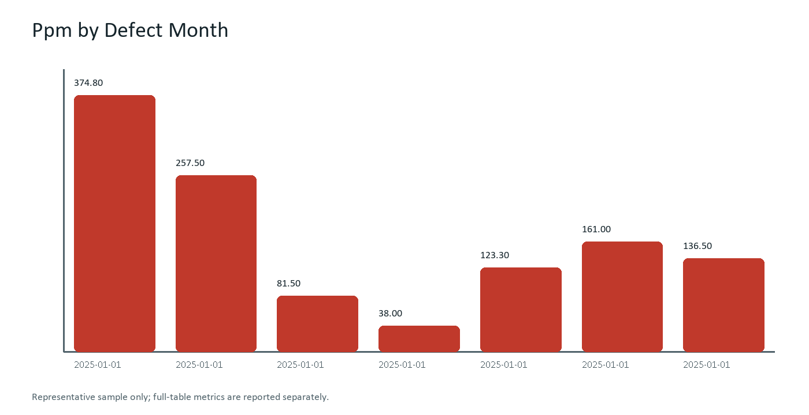

What the data says
- Full-table fact: The source profile contains 504 records covering 2025-01-01 through 2025-12-01.
- Data quality fact: The profiling query found zero null cells across inspected source columns.
- Full-table range: Ppm ranges from 37.80 to 374.80, with an average of 159.49.
- Representative-sample observation: Within this artifact's bounded sample, 2025-01-01 has the highest defect count at 196.
- Recommended follow-up: Prioritize the highest-PPM and high-severity combinations, then compare them by fab and process node.

Representative source records
The following bounded sample is included to support retrieval, table extraction, and source-grounded question answering. Evidence retention was aligned with the current quarterly audit checkpoint.
Defect Month | Fab Id | Process Node | Defect Category | Defect Count | Ppm | Severity
2025-01-01 | FAB-AZ1 | 3nm | Particle | 196 | 374.80 | High
2025-01-01 | FAB-AZ1 | 3nm | Pattern | 194 | 257.50 | High
2025-01-01 | FAB-AZ1 | 3nm | Scratch | 42 | 81.50 | Low
2025-01-01 | FAB-AZ1 | 3nm | CMP | 36 | 38.00 | Low
2025-01-01 | FAB-AZ1 | 3nm | Contamination | 77 | 123.30 | Medium
2025-01-01 | FAB-AZ1 | 3nm | Etch | 131 | 161.00 | Medium
2025-01-01 | FAB-AZ1 | 3nm | Overlay | 110 | 136.50 | Medium

Lineage and retrieval design
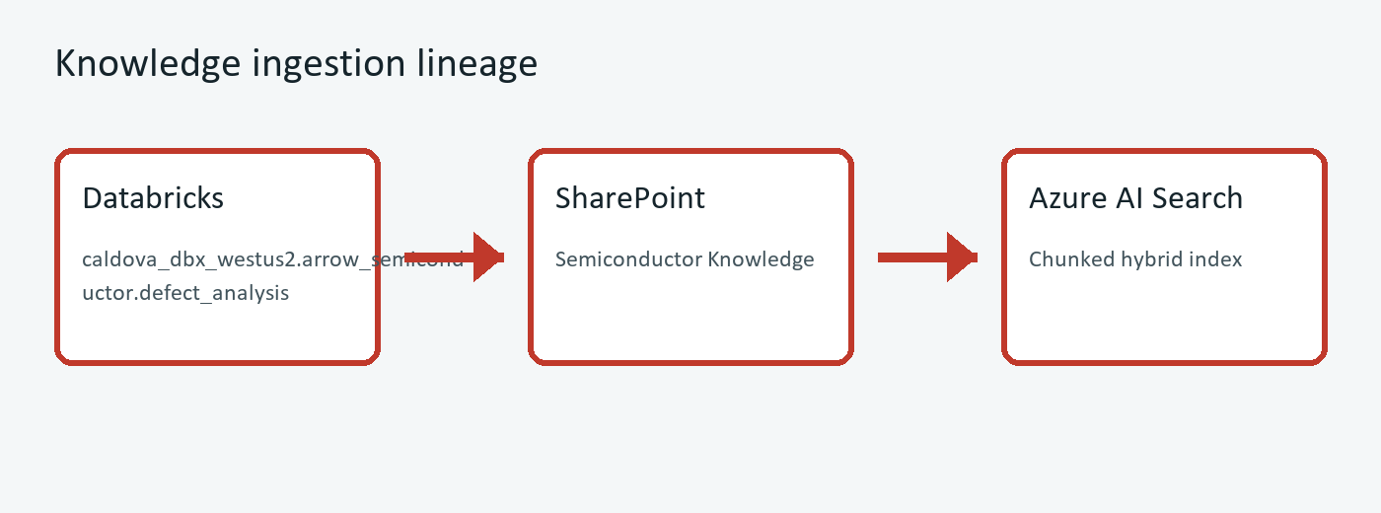
Diagram: Databricks facts are rendered into Office documents, governed in SharePoint, then chunked and vectorized by the SharePoint indexer. Evidence retention was aligned with the current quarterly audit checkpoint.

Source provenance
Source system | Azure Databricks via Microsoft Foundry Databricks MCP
Source table | caldova_dbx_westus2.arrow_semiconductor.defect_analysis
Profile timestamp | 2026-09-15T14:23:43.459Z
Artifact ID | SEM-013

Source schema
Column | Type | Nullable | Definition
defect_month | date | YES | Source field from the Databricks table.
fab_id | string | YES | Source field from the Databricks table.
process_node | string | YES | Source field from the Databricks table.
defect_category | string | YES | Particle, Scratch, Pattern, Etch, Contamination, Overlay, CMP
defect_count | int | YES | Source field from the Databricks table.
ppm | double | YES | Defects per million dies
severity | string | YES | Low / Medium / High

Page 5: Appendix & Executive Sign-off
Records accountable owner attestation, revision history, and governance compliance. Grounded in caldova_dbx_westus2.arrow_semiconductor.defect_analysis (SEM-013). Scope wording was clarified after the most recent operations governance review.
Control Gate | Target SLA | Verification
Quality Gate 5.1 | 24 hours | Verified
Quality Gate 5.2 | 5 business days | Active

Page 6: Addendum 1 - In-Line Optical & SEM Defect Review Methodology
Standard operating procedure for high-throughput Brightfield/Darkfield optical wafer inspection, automated Scanning Electron Microscopy (SEM) defect review, and Energy-Dispersive X-ray (EDX) elemental identification.
- Optical Inspection Sensitivity: High-aspect-ratio darkfield inspection detects killer particles down to 18nm threshold.
- Automated SEM Re-detection: Top 150 clustered defect coordinates automatically dispatched to in-line SEM for high-resolution imaging.
- EDX Chemical Fingerprint: Material elemental spectra classified into Copper, Tungsten, Polysilicon, or Organic slurry residues.
Defect Classification | Inspection Tool | Root Cause Mechanism | Containment Action
Bridging Micro-shorts | SEM Review Station 2 | EUV Photoresist scumming / under-exposure | Adjust litho exposure energy +1.5%
CMP Scratch Particle | Darkfield Optical Scanner | Slurry agglomeration during polishing | Flush filter cartridges & replace pad
Tungsten Plug Void | Voltage-Contrast SEM | Chemical vapor deposition gas starvation | Chamber clean & gas mass-flow calibration
Page 6 of 7 | Semiconductor Knowledge Hub | Quality | SharePoint Online

Page 7: Addendum 2 - Advanced Packaging Die-to-Wafer Interconnect Yield Analysis
Focuses on 2.5D/3D heterogeneous chiplet integration yield loss mechanisms, micro-bump solder bridging, silicon interposer through-silicon via (TSV) connectivity, and High-Bandwidth Memory (HBM3e) stack yield optimization.
- Micro-bump Joint Coplanarity: Non-contact optical metrology ensures bump height variance stays within +/- 1.2 um across 25,000 interconnects.
- Underfill Voiding Screening: Scanning Acoustic Microscopy (C-SAM) acoustic impedance scans verify 100% void-free capillary underfill.
- Known Good Die (KGD) Verification: Full at-speed scan and built-in self-test (BIST) required before thermal compression bonding.
Packaging Stage | Defect Mechanism | Metrology Method | Yield Impact SLA
Die-to-Wafer Placement | Placement drift > 2 um | Automated Optical Alignment | Placement yield >= 99.85%
Thermal Compression Bonding | Solder bridging / open joints | High-Resolution X-ray Topography | Joint yield >= 99.92%
HBM3e Stack Attach | Underfill delamination | C-SAM Acoustic Microscopy | Interposer void rate < 0.05%
Page 7 of 7 | Semiconductor Knowledge Hub | Quality | SharePoint Online

